**Node JS Project CICD**

**-------------------------------------------**

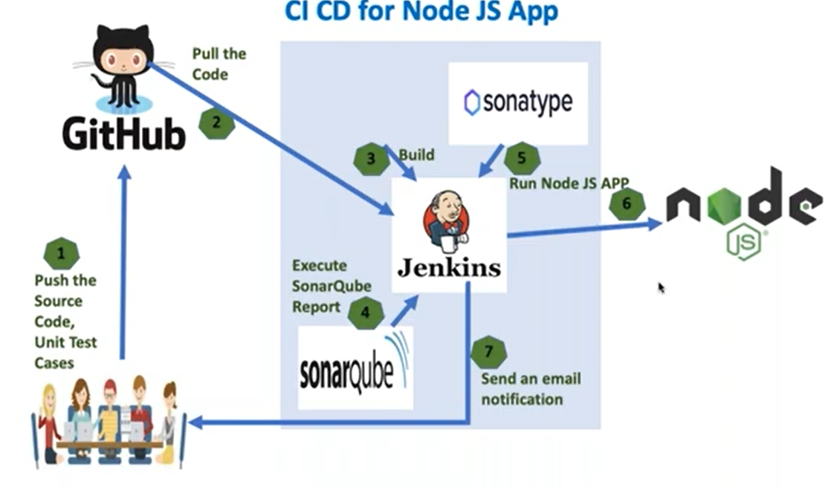

. For this we should have that Node Js application.

|  |  |  |
| --- | --- | --- |
|  | Java project | NodeJS-project |
| If you want to do a build | mvn clean package | npm install |
| If you want to run the Unit test cases | mvn test | npm test |
| If you want to execute the SonarQube Report | mvn sonar: sonar | npm run sonar |
| If you want to Upload Artifact into the Nexus artifacts repository | mvn deploy | npm publish |

“Npm” mean Node package manager

Create a new job with name of NodeJS-pipeline and select the pipeline project type.

1st Stage – we need to get the code from the GitHub repository.

2nd Stage- Build

If you want to execute **npm command**, first we should install the NodeJS in The Linux server where our Jenkins is Installed.

Steps to Install the NodeJS in the Linux Server:

**Login into Linux server and switch to the root user using below command.**

**Switch to sudo su –**

**Install the NodeJS package as follows. In RedHat distribution**

**yum install nodejs -y**

**yum install npm -y**

**npm -v**

The command cat /etc/*release. This Command to know the details the Linux distribution and version you are using.

Package.json🡪 In this file it is going keep that all the node Module names.

If you want to use the different version for that we have to install the plugin in the Global to Configuration in the manage Jenkins.

Steps to Install the NodeJS in the Jenkins Server:

Click on the Manage Jenkins-🡪install the Plugin--🡪Plugin🡪nodejs

Then Go to Manage Jenkins🡪Tools🡪we can find nodejs. Click on Add NodeJS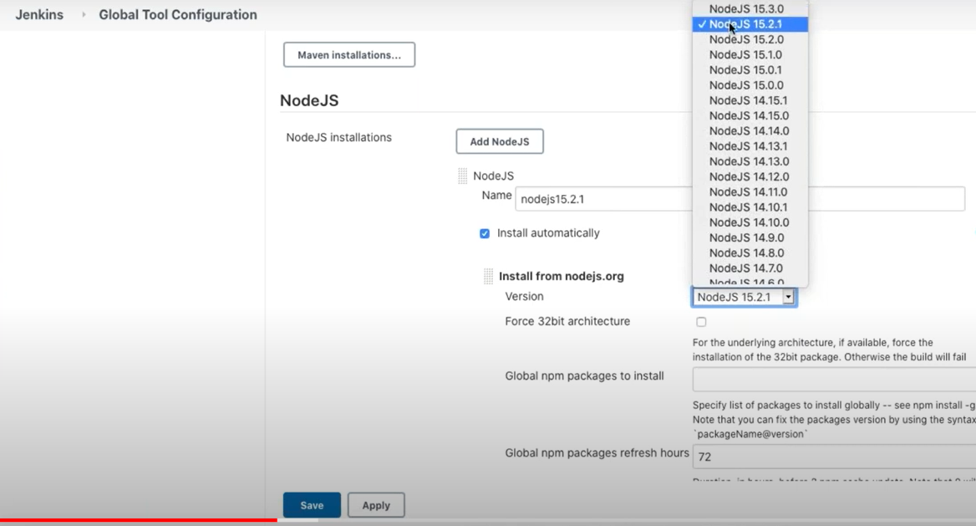

Stage 3- Execute the SonarQube Report: ---

We have Configure the SonarQube server details in sonar-project.js file

. Sonar Login /Password/Token.

Stage 4-Upload the Artifacts in to the Artifacts repositor.

For that we have create one repository in the nexus server.

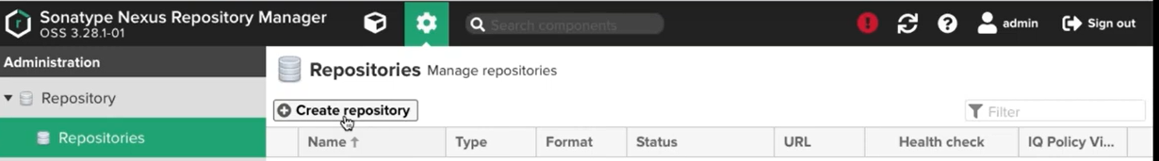

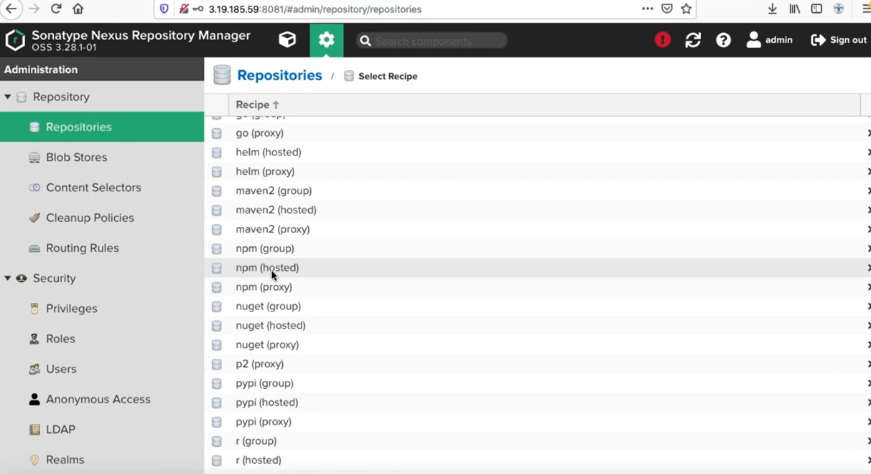

Select the npm(hosted)— and create the new repository.

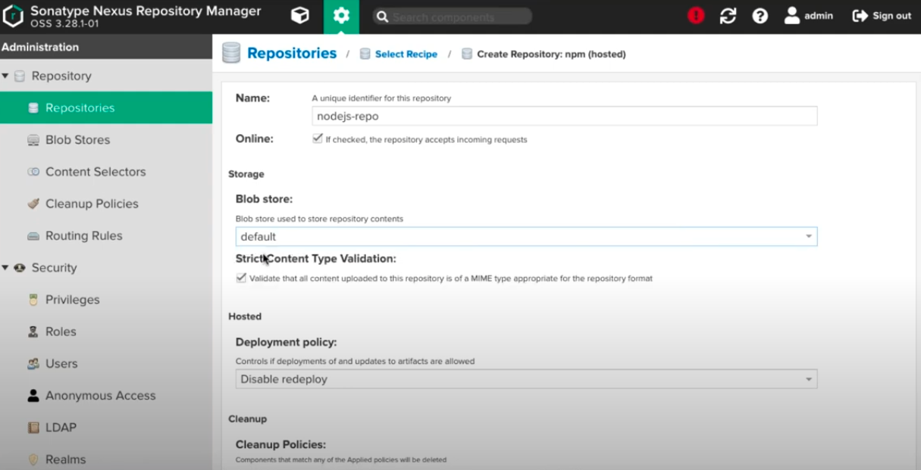

Take that repository <Url:-->

In the Nodejs we are configure in the packge.json

In Nodejs We have configure the nexus credentials in .npmrc file.

In this file we are use the propriety called as auth

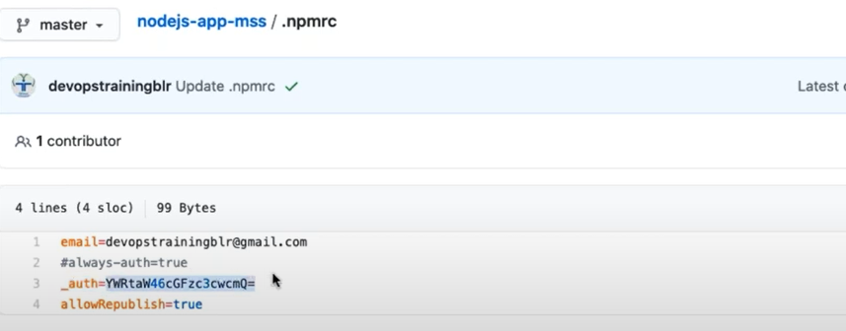

This is Base64 encryption for that we have use one command and generate the one Token.

echo -n “nexususername:nexuspassword” | openssl base64

Syntax: echo -n”admin:123456789” | openssl base64



Stage 5 Run the Application. For That we use that npm run command

Nodejs Pipeline Script: --

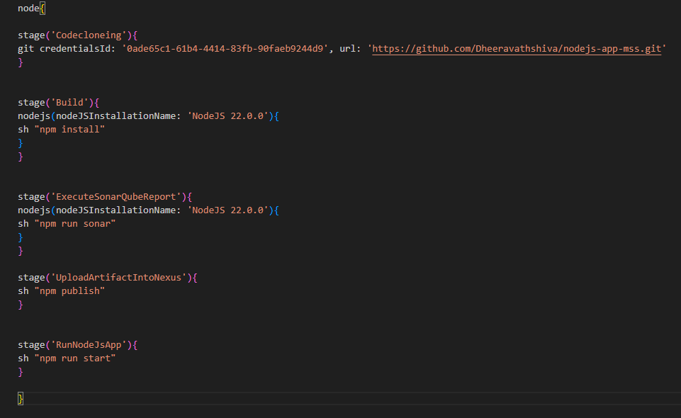

Now we can to access this application with the port number 9981

<http://ipaddress/9981/>

**Thank you**